Title: Analyzing Social Media Engagement: Insights from Video and Photo Content Interactions"

Student Name: Saideep Giri
Student ID: 23068319
GitHub Link:

Introduction:
The provided dataset contains social media engagement metrics for posts, including video and photo content. Each entry is identified by a unique status ID and includes details such as the type of content, publication time, and various user interactions, such as reactions (likes, loves, wows, etc.), comments, shares, and total reactions. This data offers valuable insights into how different types of content perform in terms of audience engagement, enabling analysis of trends and helping to optimize content strategies on social media platforms.

Abstract
The provided data contains social media engagement metrics for posts across various media types (video and photo). Each entry is identified by a unique status ID and includes the type of content (video or photo) as well as the time of publication. The dataset captures detailed interaction metrics for each post, such as reactions (like, love, wow, haha, sad, angry), comments, shares, and the total number of reactions.

Descriptive Statistics Report:

The following descriptive statistics are calculated for the numeric columns in the dataset:
The provided dataset contains several social media engagement metrics, including reactions (likes, loves, wows, etc.), comments, shares, and other related variables. The following report summarizes key statistics and insights derived from the dataset.
The following descriptive statistics have been computed for the numeric columns of the dataset:
- Number of Reactions (num_reactions):
- Mean: 230.12 – On average, posts receive 230 reactions. Standard Deviation: 462.63 – The reactions vary significantly from the mean. Min: 0, Max: 4710 – The number of reactions ranges from none to over 4700. Median 59.5.219 – The median value indicates that half the posts receive fewer than 59.5 reactions, and the 75th percentile shows that 75% of the posts receive fewer than 219 reactions.
- Number of Comments (num_comments):
Mean: 224.36 – Posts generally receive an average of 224 comments. Standard Deviation: 889.64 – There is significant variation in the number of comments. Min: 0, Max: 20,990 – Some posts may receive no comments, while others can receive up to 21,000. A large portion of posts receives few or no comments, and the upper quartile receives up to 23 comments.
- Number of Shares (num_shares):
Mean: 40.02 – On average, posts are shared 40 times. Standard Deviation: 131.60 – The number of shares varies widely. Min: 0, Max: 3424 – Some posts have no shares, while others can be shared thousands of times. Many posts are not shared or shared only a few times.

Summary Statistics for Numerical Variables:
Reactions and Comments:
- The average number of reactions per post is 230.12, with a wide variation as indicated by the high standard deviation of 462.63. The median number of reactions is 59.5, showing a skew towards posts with fewer reactions. The average number of comments is 224.36, with a standard deviation of 889.64, which suggests a significant variation in comment activity across posts. The median number of comments is 4, indicating a relatively small proportion of posts generating most of the comments.
Likes and Loves:
- Likes appear to be the most common reaction, with an average of 215.04 and a high variation (standard deviation of 449.47). The median number of likes is 58, which is much lower than the mean, suggesting a small number of posts accumulate most of the likes. Loves have a much lower mean of 12.73 and are also highly variable, with a standard deviation of 39.97.
Emotional Reactions:
- Wows have an average of 1.29, with a high skew (skewness of 18.25) and kurtosis of 415.59, indicating that most posts receive few or no 'wow' reactions, while a few posts garner a disproportionately large number. Hahas (laughing reactions) have an average of 0.70, with high skewness (20.31) and kurtosis (587.18), pointing to a very small number of posts getting a high count of 'haha' reactions. Sad’s (sad reactions) have an average of 0.24, and Angrys have an average of 0.11, both showing similar distributions with skewness values of 17.58 and 19.51, respectively.
Exploratory Data Analysis (EDA):
The histogram for the 'num_reactions' column reveals the distribution of reactions across posts. Key findings include:
- Right-Skewed Distribution: Most posts receive a small number of reactions, while a few posts generate significantly more engagement. Outliers: A small subset of posts have an exceptionally high number of reactions, with some reaching up to 4,710 reactions, indicating viral posts. Engagement Pattern: The data follows a typical Pareto distribution, where a few posts drive the majority of reactions. In conclusion, the majority of posts receive minimal reactions, but identifying the characteristics of the high-engagement posts can help improve future content strategies.

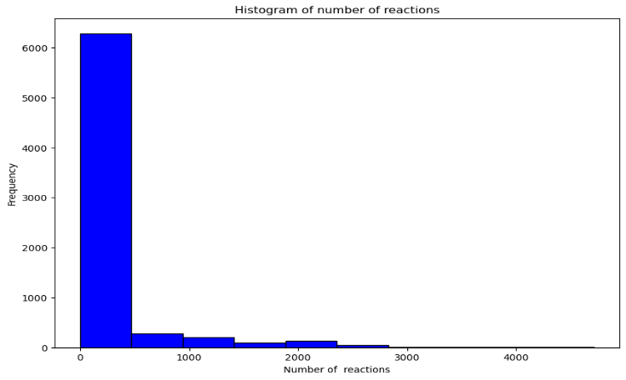

Scatter Plot Interpretation:

Function Definition defines the function scatter_plot with three parameters: data (the DataFrame), x_col (column for x-axis), and y_col (column for y-axis). Figure Configuration sets the figure size to 10 by 7 inches for better visualization. Plots the data points with x-values from x_col and y-values from y_col. The points are red with an opacity of 0.8. Plot Title and Labels: Adds a title and labels for both x-axis and y-axis using the provided column names.

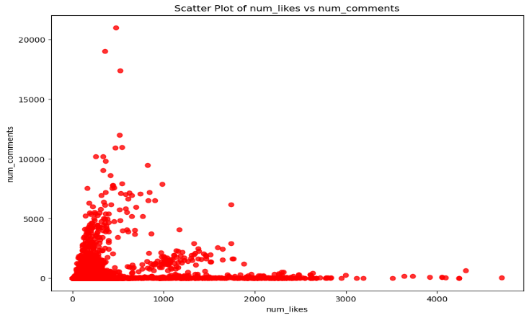

Correlation Heatmap:
The correlation matrix provides insights into the relationships between different variables in the dataset.
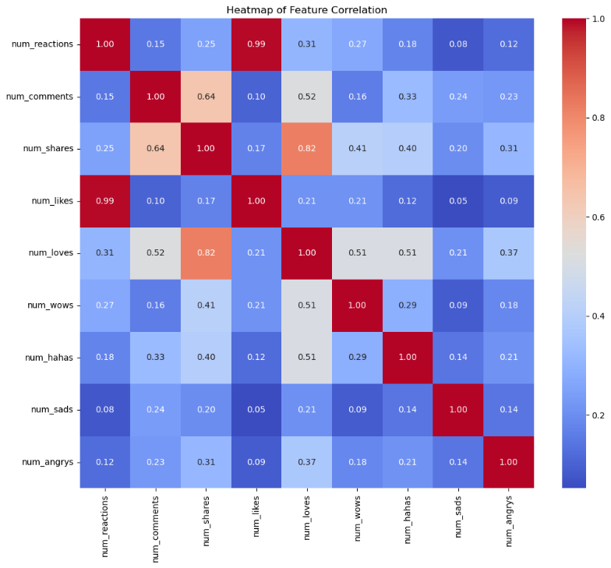

It first computes the correlation matrix using the corr() method, which measures the linear relationship between pairs of variables. The heatmap is then plotted using the seaborn library, with the correlation values annotated on the map. The coolwarm color palette is used, where darker shades represent stronger correlations.

In the heatmap, the variables num_likes and num_comments show the highest correlation, with a value of 0.99, indicating a very strong linear relationship. This suggests that the number of likes and comments are closely related in the dataset. The visualization helps to quickly identify patterns and relationships between features, aiding in further analysis and feature selection.
Silhouette scores are calculated for different numbers of clusters (ranging from 2 to 10). The silhouette score measures the compactness and separation of the clusters. The optimal number of clusters is selected based on the highest silhouette score.

Clustering Visualization:
Elbow Method:
Elbow plot is to help determine the optimal number of clusters for K-Means clustering. The x-axis represents the number of clusters, ranging from 1 to 10, while the y-axis shows the corresponding distortion values, ranging from 0 to 6000. Centers.
The plot helps identify the "elbow" point, where the rate of distortion reduction slows significantly, suggesting the ideal number of clusters. By visually inspecting the plot, users can choose the optimal cluster count that balances model complexity and accuracy, avoiding both overfitting and underfitting.

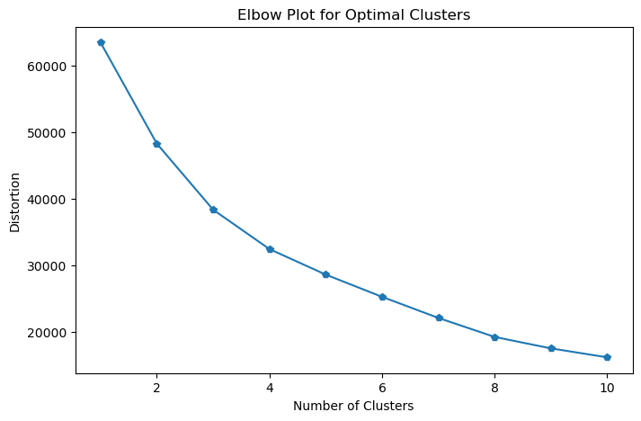
K-Mean Clustering
K-Means clustering on the dataset and visualizes the results using a scatter plot. The process begins by scaling the input data using StandardScaler, ensuring that each feature has a mean of 0 and a standard deviation of 1. The K-Means algorithm is then applied with a specified number of clusters, in this case, 3 clusters (n_clusters=3), and the cluster labels are assigned to the data.
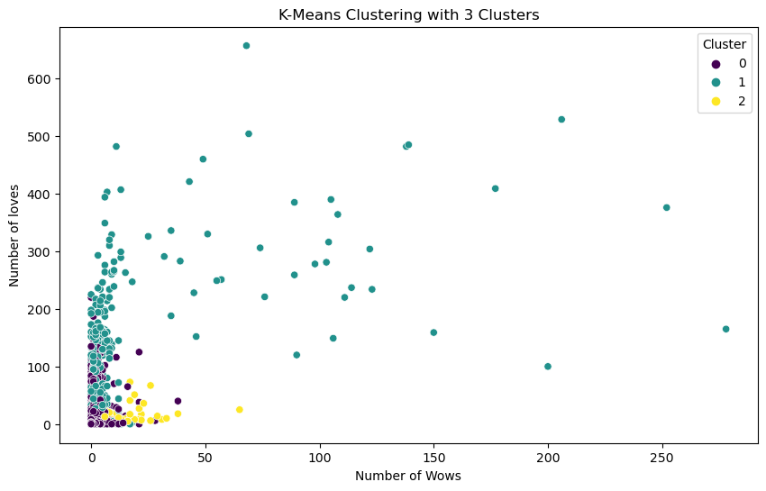
After clustering, the data is plotted with a scatter plot, where the x-axis represents the number of "wows" (num_wows) and the y-axis represents the number of "loves" (num_loves). The points are color-coded according to the assigned clusters using the 'viridis' color palette. The resulting plot helps visualize how the data points are grouped into 3 distinct clusters based on their "wows" and "loves" values.
The report of this clustering process shows that the K-Means algorithm has effectively grouped the data into 3 clusters. By examining the scatter plot, it is possible to see the distribution of the data points across the clusters, revealing patterns and trends in the relationships between the number of "wows" and "loves".

Linear Regression Fitting
The provided code performs linear regression to model the relationship between the number of likes (num_likes), shares (num_shares), and the target variable, the number of reactions (num_reactions). Here's a breakdown of the process:
1. Data Preparation and Model Fitting
- The LinearRegression model from sklearn is used to fit the data.
- The independent variables, num_likes and num_shares, are selected as the features (X), while the dependent variable, num_reactions, is selected as the target (y).
- The model is trained on this data using model.fit(X, y), which finds the best-fitting line that minimizes the residual sum of squares between the observed and predicted values.
2. Prediction and Visualization
- Once the model is trained, it predicts the num_reactions values based on the input features using model.predict(X).
- A scatter plot is created, where the x-axis represents num_likes, the y-axis represents num_reactions, and each data point is shown in purple.
- A red regression line is added to the plot, representing the linear fit between num_likes and num_reactions. This line visually illustrates the relationship that the model has learned.
3. Performance Evaluation
- The Mean Squared Error (MSE) of the model is computed using mean_squared_error(y, predictions). MSE measures the average squared difference between the actual values and the predicted values. The lower the MSE, the better the model's fit.
- The MSE is printed with 3 decimal places, providing a quantitative evaluation of the model's accuracy. For example, if the MSE is 1500, it suggests that, on average, the predictions are off by 1500 squared unit.

